LUMPY SKIN DISEASE
INTRODUCTION AND HISTORY
It is an infectious viral disease of cattle and buffaloescaused by Capri pox virus of family Poxviridae,transmitted by arthropod vectors such as mosquitoes,biting flies and ticks. The disease was first reported in Zambia as
an epidemic in 1929.It was found in southern and eastern Africa, but in the 1970s extended to North West through the continent into sub-Saharan West Africa. Since 2000 it has spread to several countries of the Middle
East .Its incidence is highest in wet summer weather, also occur in winter
CLINICAL SIGNS
It is characterised by mild fever for 2-3 days followed by development of cutaneous nodules on the skin.Nodules are circumscribed,firm,1-5 cm round,raised and there is involvement of subcutaneous tissue and
sometimes muscles.Lesions are also seen in mouth, pharynx and respiratory tract.Emaciation and enlarged lymph nodes are also observed.Submaxillary Oedema,Oedema of limbs,lacrimation,Nasal discharge, Corneal
oedema ,reduction in milk production,abortion ,infertility are the other clinical signs.incubation period varies from 4-28 days.
Morbidity rate is around 10-20%and Mortality rate is around 1-2%
REFERRAL OF SAMPLES
Skin scabs/skin biopsies
Blood in EDTA vials
Nasal swabsfrom animals in LSD suspected outbreaks should be referred to ICAR-NIHSAD, Bhopal for laboratory testing
DIAGNOSIS
Clinical signs and symptoms,Virus isolation from the scabs or blood sample,PCR(Polymerase chain reaction tests).
TREATMENT
Sick animals are to be kept in isolation
Symptomatic treatment of affected animals may be carried out in consultation with a Veterinarian .
Administration of antibiotics for 3-5 days to prevent secondary bacterial infection.
Administration of anti inflammatory and antihistamine preparation.
Application of antiseptic lotion or ointment with fly repellent property over the eroded skin is advised.
Parentral or oral multivitamin is advised.
Feeding of liquid food ,soft feed and fodder and succulent pasture is recommended
Recovered Animals develop Immunity.
PREVENTION AND CONTROL
Reduce the vector population in affected areas.
Immediate isolation of sick/ infected animals from the healthy animal.
Carcass should be disposed of by deep burial.
Unaffected animal should be applied with insect repellent.
Strict control of animal movement from affected areas to free areas should be ensured.
Trade of live cattle ,participation in shows immediately upon confirmation of the disease.
All biosecurity measures and strict sanitary measures for disposal of personal protective equipments.
Cattle markets located within 10 km radius of the epicentre of infection should be closed.
Through cleaning and disinfection of affected personnel , premises and contaminated environment with appropriate chemicals/ disinfectants.
CASE REPORT
A Cross bred jersey cow belonging to Joy , Aanakkadan , Vellarappilly , Sreemoolanagaram Panchayath with the complaint of nodular eruptions on all over the body, sudden drop in milk production, oedema of limb
and brisket region and dyspepsia was reported to Veterinary Hospital , Sreemoolanagaram in December 11 ,2019. A thorough physical examination revealed that the cow was febrile with rectal body temperature of
103.4F and had small to large sized circumscribed nodules on all over the body. Besides, there was swelling of both prescapular and prefemoral lymph nodes.There was Respiratory distress alsofor that Animal.Nodular
Lesion samples and blood samples were taken by the team of Doctors from ADCP –Ernakulam and send to CDIO,Palode, Thiruvananthapuram for sending the samples to Bhopal High Security Lab.
Treatment:Antibiotic(Dicrysticin 5g vial i/m)
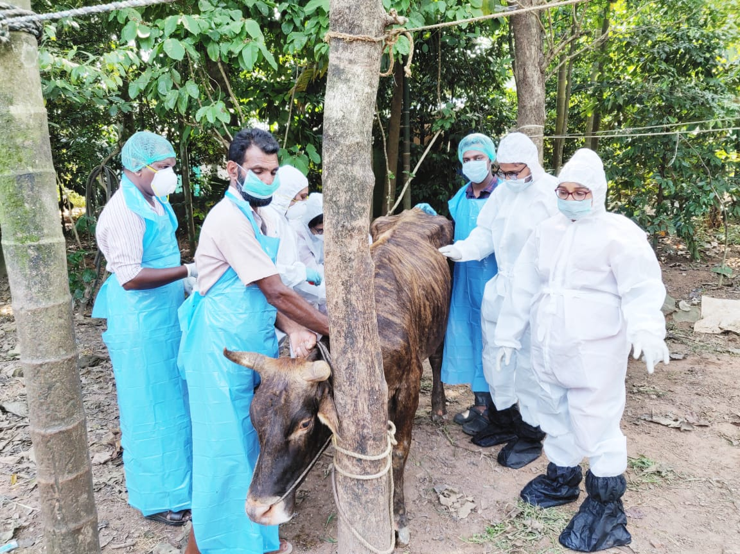
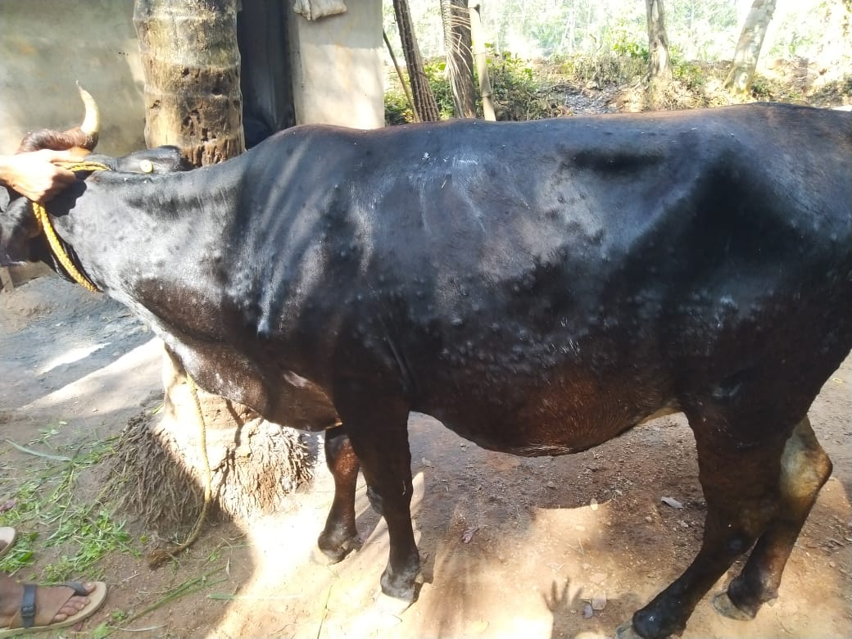
Antinflammatory(Meloxicam 15ml i/m)
Antihistaminics(Avilin vet 10 ml i/m)
Endectoparasiticide(Ivermectin 10 ml s/c)-on the 1st day
Topical application of Acriflavin Lotion
Animal was completely normal after 2 weeks.
Production came to almost normal after 15 days.
Dr. SHIRLY.T.R
SENIOR VETERINARY SURGEON,SREEMOOLANAGARAM

